* Data Storage
  + Max Heapify
    - 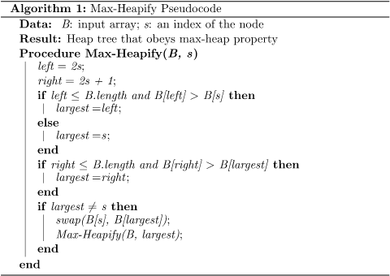
  + BST
    - 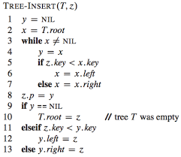
    - 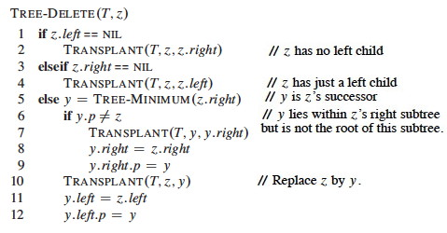
  + RB Tree
    - 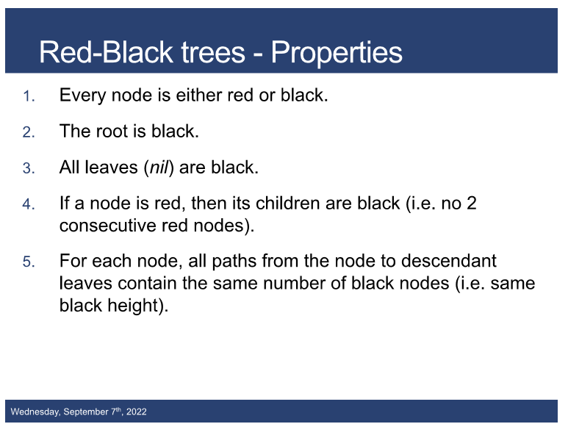
    - Rotate
      * 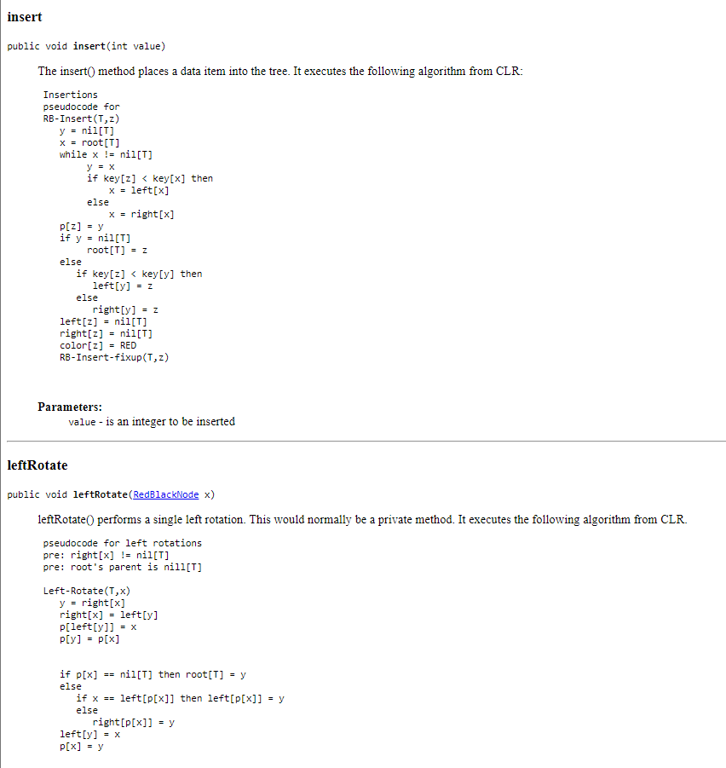
      * 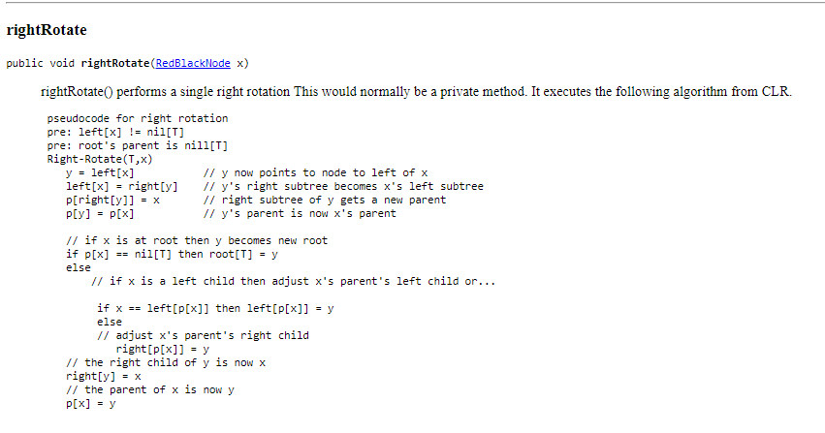
  + Union-Find
    - 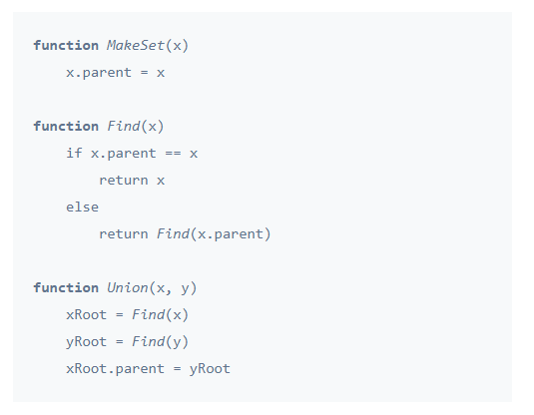
* Sorting
  + MergeSort
    - 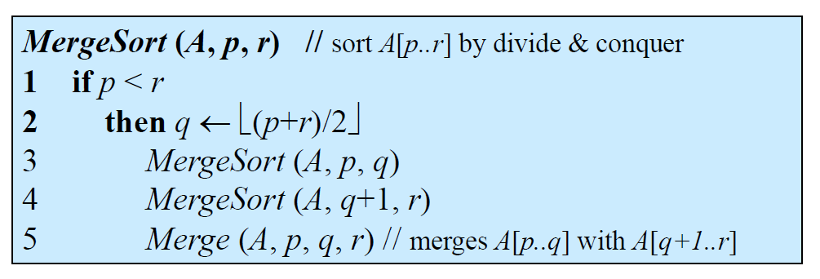
    - 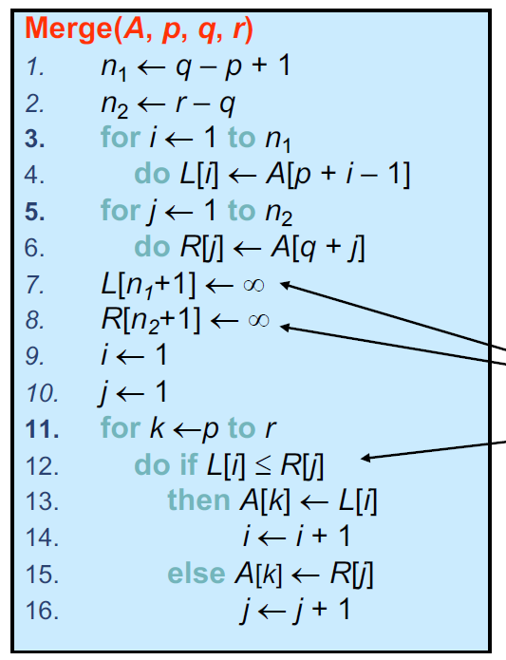
* DP
  + KnapSack
    - 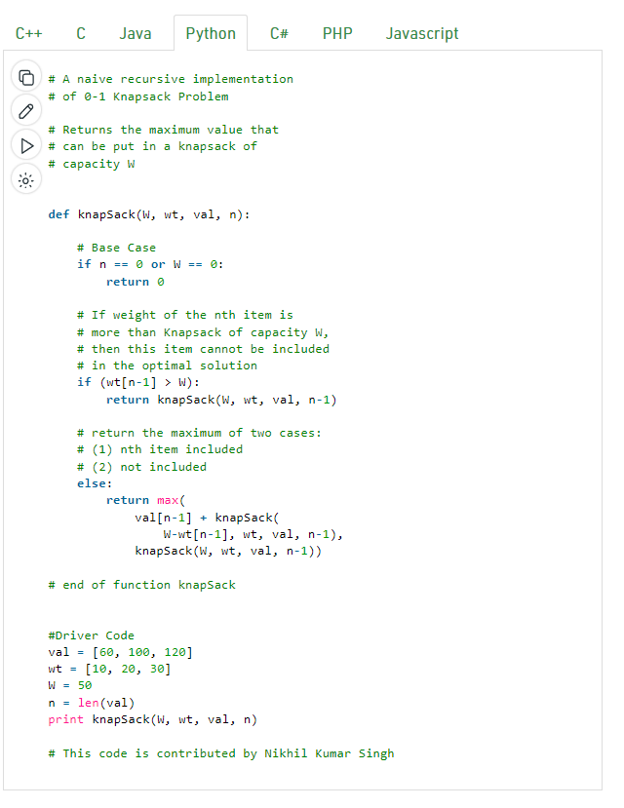
  + Dominos
    - 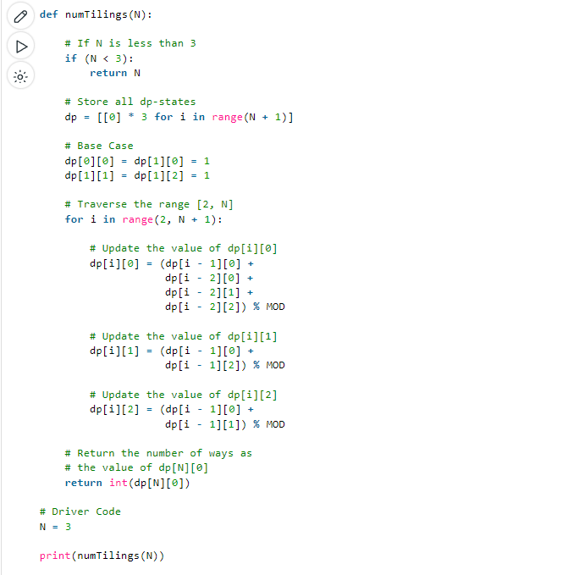
* Graphs
  + DFS/BFS
    - 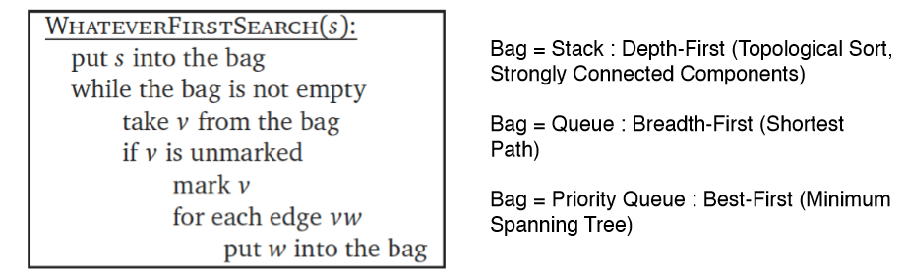
  + Topological Sort
    - 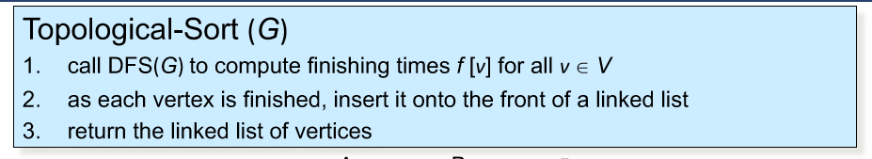
  + Strongly Connected Components
    - 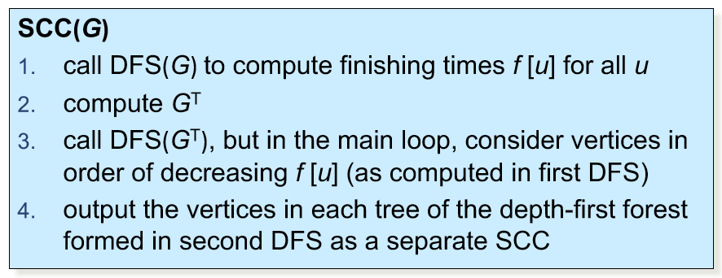
  + Dijkstra
    - 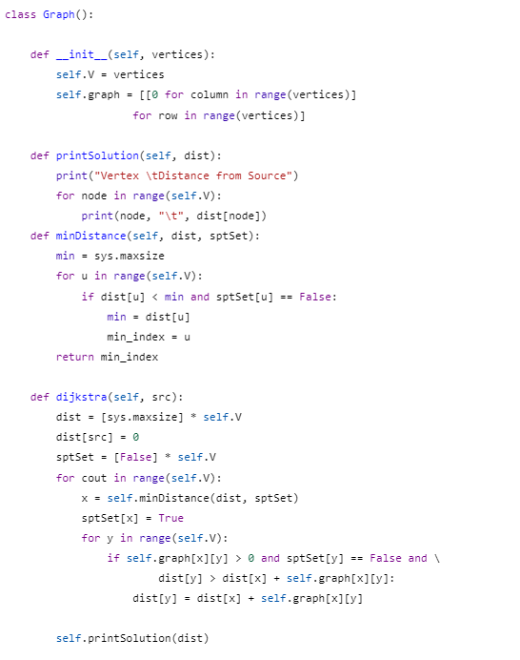
  + Bellman Ford (negative weights)
    - 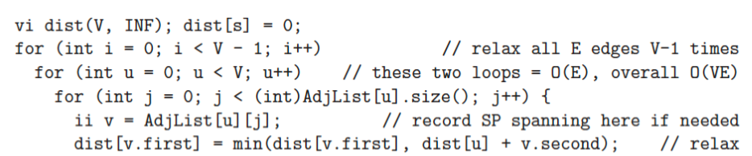
  + Bellman Ford (negative weights)
    - 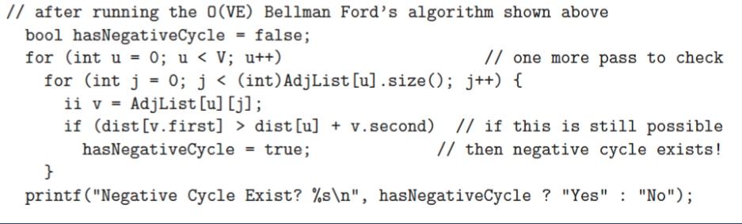
  + Floyd Warshall (Adjacency Matrix)
    - 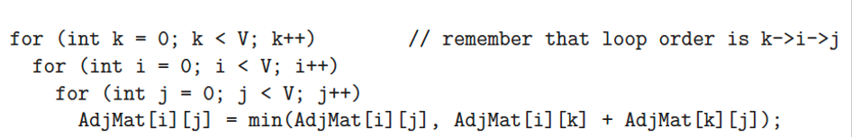
  + 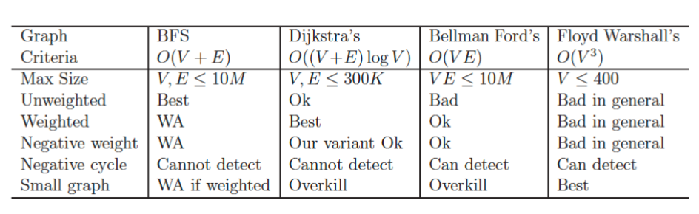
  + Minimum Spanning Tree
    - Kruskal
      * 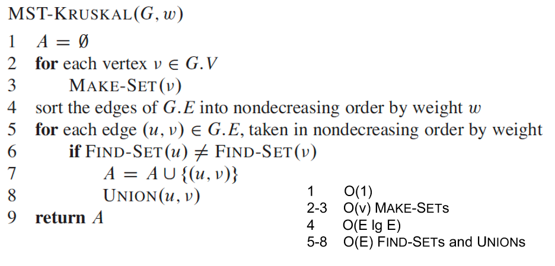
      * Find second best by computing multiple MST and excluding one edge each time from original
    - Prim
      * 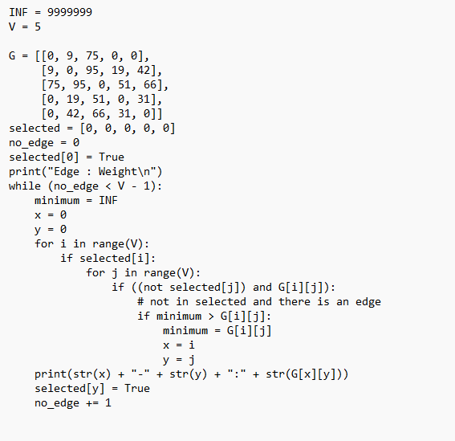
* Sorting Strings
  + Bubble
    - 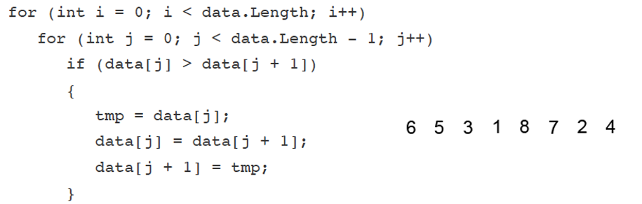
  + Insertion
    - 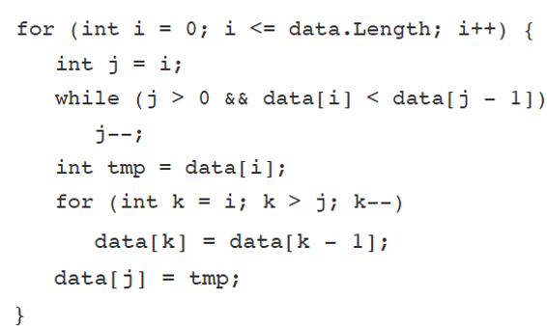
  + Heap
    - 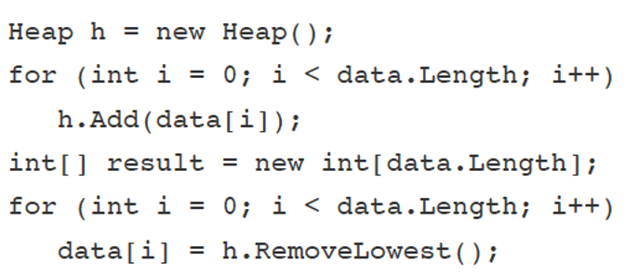
  + Quick
    - 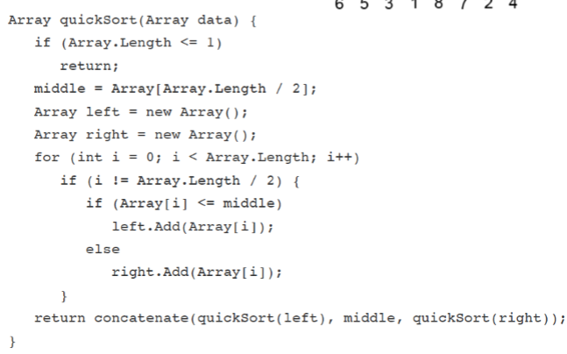
  + Counting
    - 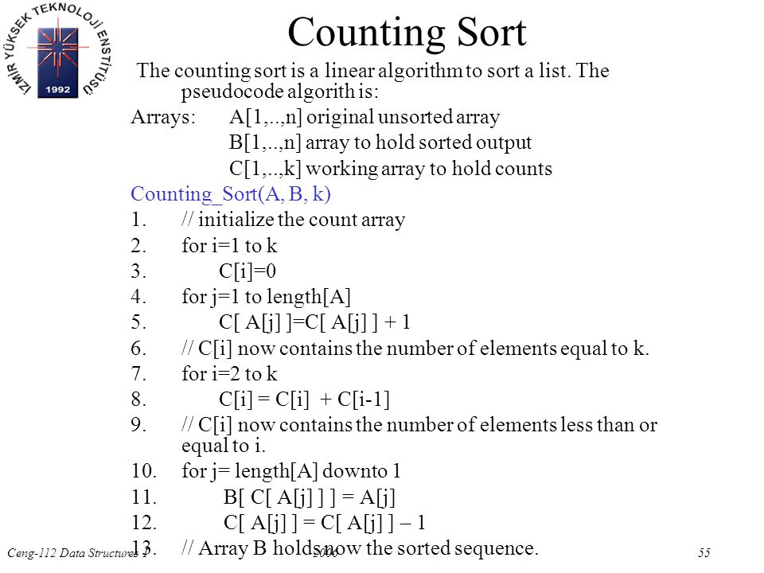
  + Radix
    - 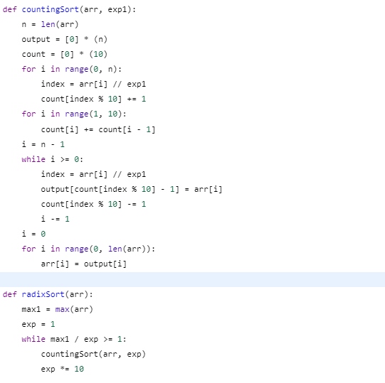
  + Knuth-Morris-Pratt
    - 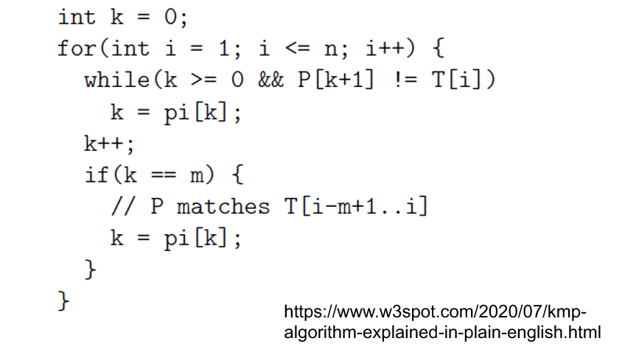
  + Suffix Array
    - 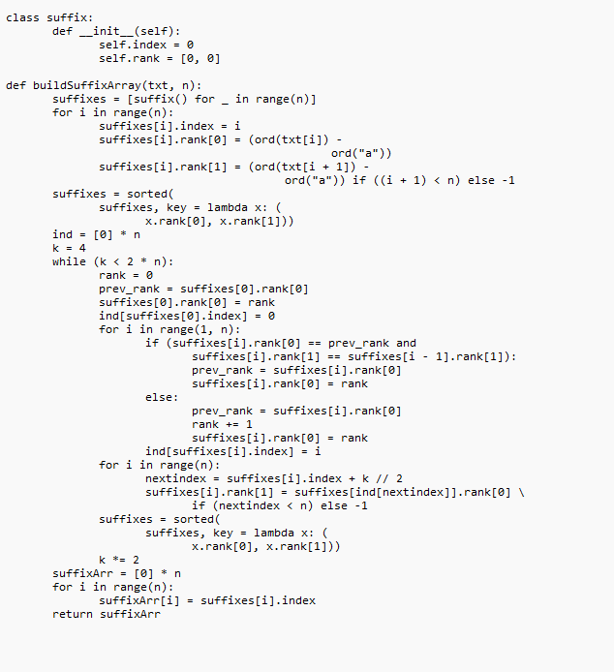
* Geometry
  + Euclidean Distance
    - 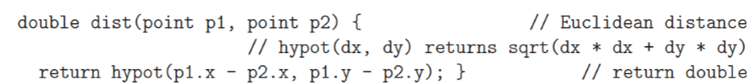
    - 
  + Chord
    - 2 × r × sin(θ/2)
  + Sector
    - 𝜃/360o (𝜋r2)
  + Segment
    - A = (½) × r2 (θ – Sin θ)
  + Heron’s Formula for Triangles
    - Area = Square root of√s(s - a)(s - b)(s - c) where s is half the perimeter, or (a + b + c)/21
  + Radius of Triangle Outer/Inner Circle
    - r = ABC / 4A, and for a circle inscribed in a triangle is r = A / S where S = (A + B + C) / 2
  + Shoelace Area Formula
    - Graphical user interface, text

      Description automatically generated
  + Check if Point in Convex Polygon
    - Calculate area, calculate area again using point, if second area equals first, then inside
  + Check if Point in Non-Convex
    - Start Ray outside to point, count intersections with boundary, if odd (point inside), if even (outside)
  + Check if Convex
    - Text

      Description automatically generated
  + CCW
    - CCW(A,B,C) = (B-A) x (C-A)
    - >0 if ABC is left turn, 0> if ABC is right turn
  + Check if Two Lines Intersect
    - Text

      Description automatically generated
  + Graham Scan (Convex Hull)
    - Text

      Description automatically generated
    - Text

      Description automatically generated
  + Sweep Line
    - Only check within last smallest distance found
    - Text, letter

      Description automatically generated
* Mathematics
  + Fractions
  + Addition
    - 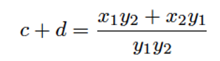
    - 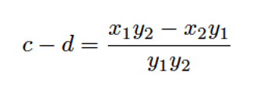
    - 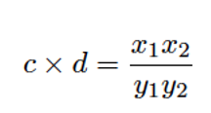
    - 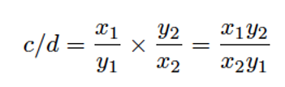
  + Polynomials
    - Horner’s Rule
      * 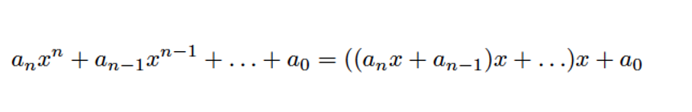
    - Multiplication/Division
      * 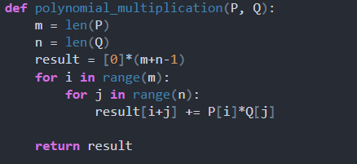
    - Root Finding
      * One
        + 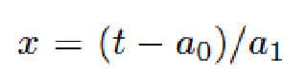
      * Two
        + 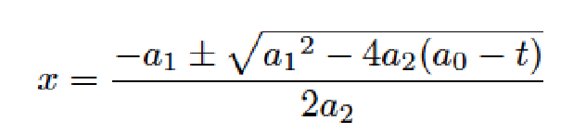
      * N
        + 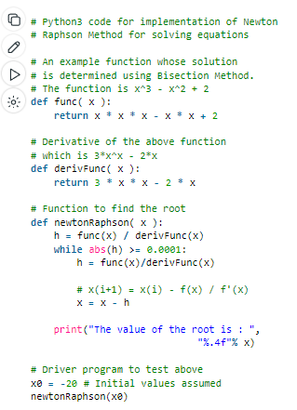
  + Logarithms
    - 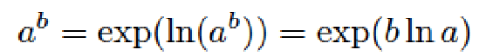
  + Sum of Powers
    - 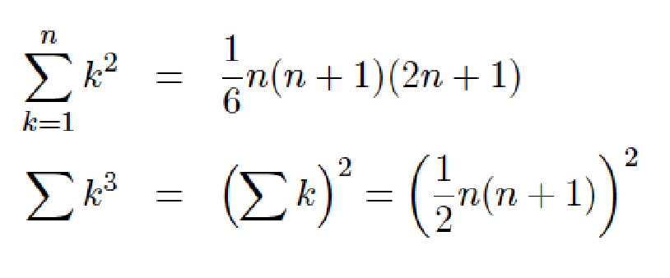
  + Exponents
    - 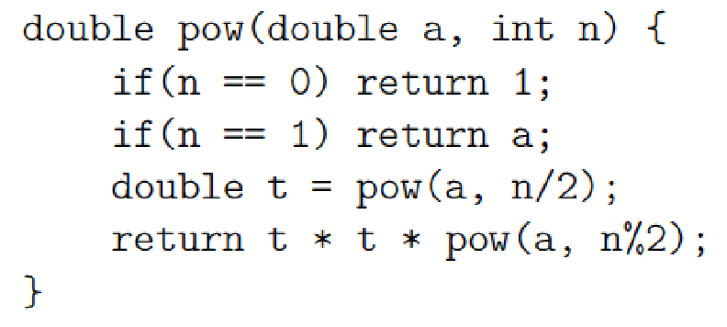
  + Modulo
    - 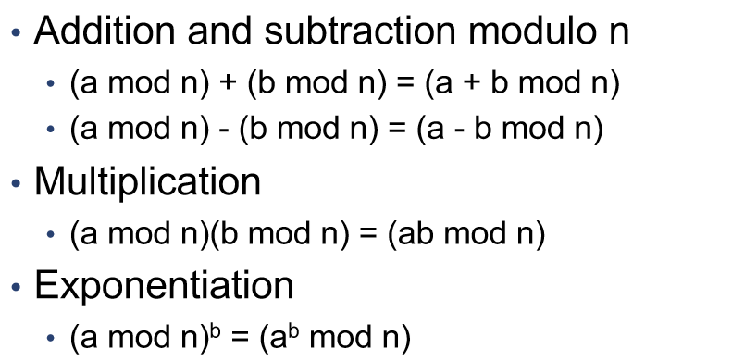
  + Prime
    - Prime Numbers Up to N
      * Below 107
        + 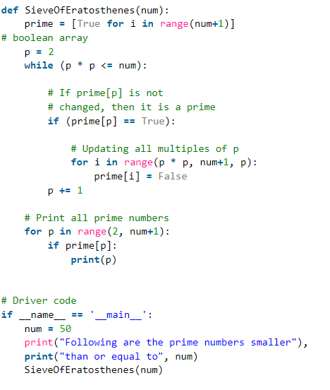
      * Above 107
        + 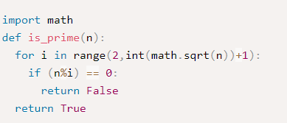
    - Prime Factors
      * 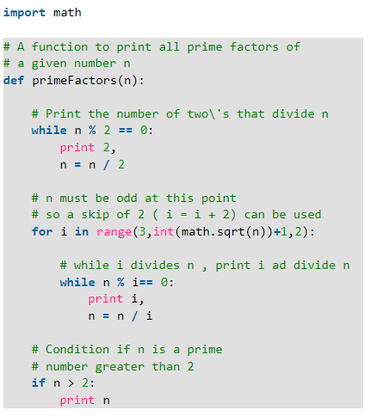
    - PrimeFactors Count
      * 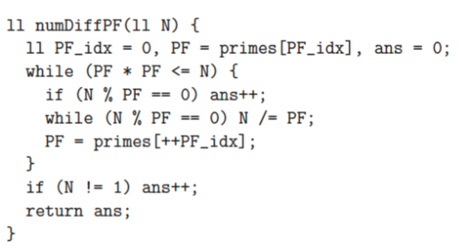
    - For Many Numbers (PrimeFactors)
      * 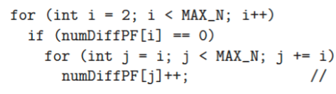
    - Find Number of Relative Primes Up to N
      * 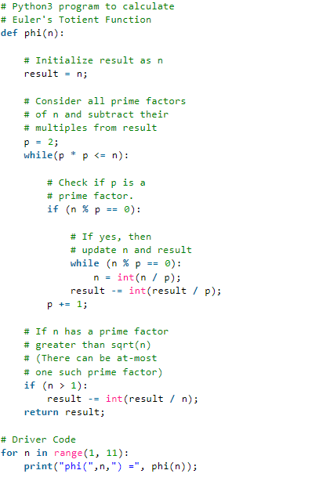
  + Number Theory
    - GCD
      * 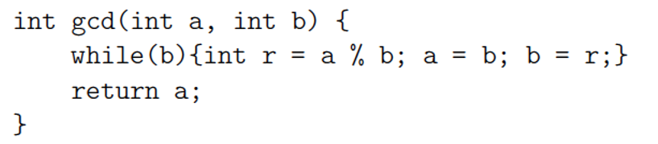
    - LCM
      * 
  + Combinatorics
    - Fibonacci
      * Up to 75
        + 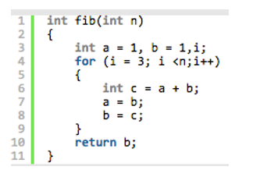
      * After 75
        + 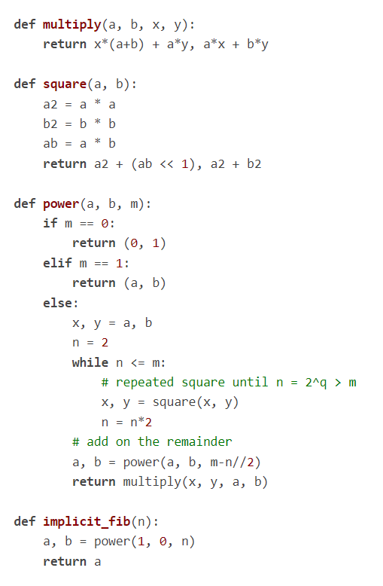
    - Cycle Finding
      * 
     